Erasmus+ experience report

**

## Student Information

**Name:** Klicken oder tippen Sie hier, um Text einzugeben.

**Degree programme:** Klicken oder tippen Sie hier, um Text einzugeben.

**Intended degree:** Klicken oder tippen Sie hier, um Text einzugeben.

**Host institution:** Klicken oder tippen Sie hier, um Text einzugeben.

**Host country:** Klicken oder tippen Sie hier, um Text einzugeben.

**Period of stay abroad:** Datum Beginn to Datum Ende

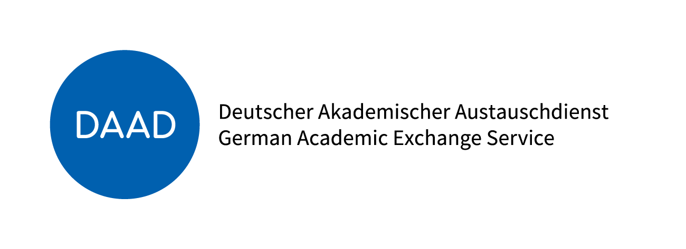 

|  |
| --- |
| ***Guidelines for Writing the Experience Report***  This brief report on your experiences provides important information for the Erasmus+ scholarship program. It should benefit future students and help improve the program. Be creative! We especially welcome innovative and original formats (e.g., photos, videos, blogs, etc.). If you have an extraordinary idea for your report, feel free to contact the International Office.  You may also share your experiences using the guiding questions below. Please answer the questions that are relevant to you — not all need to be answered. |

|  |
| --- |
| Preparation |

How did you prepare for your stay abroad?

Klicken oder tippen Sie hier, um Text einzugeben.

What motivated you to go abroad (e.g. professional, cultural, personal reasons)?

Please elaborate (bullet points or in full text).  
Klicken oder tippen Sie hier, um Text einzugeben.

***How did you find your study/internship/research placement?***

Internet research on various platforms

Through contacts (friends, family in host country)

Via the host institution

Through the University of Wuppertal

Other (please specify): Klicken oder tippen Sie hier, um Text einzugeben.

|  |
| --- |
| Host Institution & Host Country |

***How were you welcomed at the host institution?***

Welcome event

Orientation session

orientation programme

Other (please specify): Klicken oder tippen Sie hier, um Text einzugeben.

Did the host institution meet your expectations?

Yes

No

If no, why not? What did you expect?

Klicken oder tippen Sie hier, um Text einzugeben.

Did you receive support from your host institution during your stay?

Yes

No

If no, what kind of support would you have appreciated?

Klicken oder tippen Sie hier, um Text einzugeben.

Would you recommend your host institution?

Yes

Np

If no, why not? Klicken oder tippen Sie hier, um Text einzugeben.

Did you have difficulty settling into the host country?

Yes

No

If yes, what were the challenges? Klicken oder tippen Sie hier, um Text einzugeben.

Did the host country meet your expectations overall?

Yes

No

If no, why not? Klicken oder tippen Sie hier, um Text einzugeben.

|  |
| --- |
| Costs & Funding |

My average monthly expenses during my stay abroad (in euros):

Klicken oder tippen Sie hier, um Text einzugeben.

Did the Erasmus+ scholarship cover your expenses?

Yes

No

Did you have any other sources of income? If so, which ones?

Yes

No

Other income sources: Klicken oder tippen Sie hier, um Text einzugeben.

How much more did you need compared to your expenses in your home country?

Additional monthly amount: Klicken oder tippen Sie hier, um Text einzugeben.

Cost of living: What was more expensive, what was cheaper? Please give examples.

Klicken oder tippen Sie hier, um Text einzugeben.

|  |
| --- |
| Accommodation & Living Situation |

How did you find your accommodation?

With help from the host institution

With help from the University of Wuppertal

On my own initiative (e.g., online research)

Through contacts (family, friends) in host country

Other (please specify): Klicken oder tippen Sie hier, um Text einzugeben.

Living situation: Where did you live? Would you recommend it?

Klicken oder tippen Sie hier, um Text einzugeben.

How would you rate the quality and facilities of the accommodation?

excellent

good

satisfactory

poor

Other (please specify): Klicken oder tippen Sie hier, um Text einzugeben.

|  |
| --- |
| Experiences During Your Stay |

What aspects of your stay did you particularly enjoy or find important?

Klicken oder tippen Sie hier, um Text einzugeben.

Did you face any major challenges during your stay abroad?

Yes

No

If yes, what kind?

Klicken oder tippen Sie hier, um Text einzugeben.

Are you considering a career abroad or working internationally?

Yes, definitely

No, definitely not

Not sure yet

Do you believe your stay abroad will benefit your professional development?

Yes, definitely

No, I don’t think so

What differences did you notice in work/study methods compared to what you're used to?

Klicken oder tippen Sie hier, um Text einzugeben.

Were you satisfied with the overall quality of teaching/training?

Yes

No

Partly

Please explain briefly: Klicken oder tippen Sie hier, um Text einzugeben.

Were your academic achievements abroad recognized by your home university?

Yes

No

Partially

|  |
| --- |
| Language |

Were your language skills sufficient?

Yes

No

Were there opportunities to improve them locally (language courses, buddy programmes, tutoring)?

Yes

No

If yes, what kind? Klicken oder tippen Sie hier, um Text einzugeben.

|  |
| --- |
| Daily Life and Free Time |

Did the host institution offer a support programme? What did it involve?

Klicken oder tippen Sie hier, um Text einzugeben.

Were there any must-attend events or activities?

Klicken oder tippen Sie hier, um Text einzugeben.

Which language, sports, or cultural activities did you take part in?

Klicken oder tippen Sie hier, um Text einzugeben.

Did you go on trips with student groups?

Yes

No

If yes, where to and how was it organised?

Klicken oder tippen Sie hier, um Text einzugeben.

|  |
| --- |
| Conclusion |

Things to consider in general:

Klicken oder tippen Sie hier, um Text einzugeben.

What to prepare for in advance:

Klicken oder tippen Sie hier, um Text einzugeben.

Must-do experiences:

Klicken oder tippen Sie hier, um Text einzugeben.

What exceeded your expectations? What was your highlight or most memorable moment?

Klicken oder tippen Sie hier, um Text einzugeben.

What was your best experience related to your time abroad?

Klicken oder tippen Sie hier, um Text einzugeben.

What didn't go so well?

Klicken oder tippen Sie hier, um Text einzugeben.

Summarise your stay abroad in one or two sentences:

Klicken oder tippen Sie hier, um Text einzugeben.

|  |
| --- |
| Suggestions, Tips & Ideas |

Where do you see your greatest success – personally, academically, and/or professionally – after completing your time abroad?

Klicken oder tippen Sie hier, um Text einzugeben.

***What advice would you give to other students planning a stay abroad?***

* **Application process at the host institution (internship search):**

Klicken oder tippen Sie hier, um Text einzugeben.

* **Social and cultural aspects:**

Klicken oder tippen Sie hier, um Text einzugeben.

* **Language requirements:**

Klicken oder tippen Sie hier, um Text einzugeben.

* **Other tips (useful websites, contacts, housing areas, accommodation search, public transport, leisure activities, etc.):**

Klicken oder tippen Sie hier, um Text einzugeben.

Do you have travel recommendations (airlines, airports, luggage shipping, etc.)?

Klicken oder tippen Sie hier, um Text einzugeben.

Was the length of your stay ideal or would you have preferred it shorter or longer?

ideal

shorter

longer

How can students be made aware of the Erasmus+ programme?

Klicken oder tippen Sie hier, um Text einzugeben.

|  |
| --- |
| Pictures |



|  |
| --- |
| Consent |

*I agree that this report (including photos) may be published on the websites of the International Office or International Students Team as well as in printed materials of the University of Wuppertal.*

Yes

No

*I agree that my creative realisation of the report (in other formats) may be published on the websites of the International Office or International Students Team as well as in printed materials of the University of Wuppertal.*

Yes

No

*I agree that my email address may be published for students interested in PROMOS, e.g. for questions about housing, the city or host university.*

Yes

Only with prior consent

No

The experience report should be submitted as a PDF via email to the International Office ([teamoutgoing@uni-wuppertal.de](mailto:teamoutgoing@uni-wuppertal.de)). Your consent to publication is valid without a signature.